 | 7.1.31 Editors - 3D Viewport - Header - Grease Pencil - Edit mode - Stroke menu
Table of content
Edit Mode - Stroke Menu 2
Subdivide 2
Last Operator Subdivide 2
Number of Cuts 2
Smooth 2
Repeat 2
Selected Points 3
Position 3
Thickness 3
Strength 3
UV 3
Simplify 3
Fixed 3
Last Operator Simplify Fixed Stroke 3
Steps 3
Adaptive 3
Last Operator Simplify Stroke 3
Factor 3
Sample 3
Last Operator Sample Stroke 3
Factor 3
Trim 4
Join 4
Join and copy 4
Last Operator Join Strokes 4
Type 4
Leave Gaps 4
Move to Layer 4
New Layer 4
Last Operator Move Strokes to Layer 5
Grease Pencil Layer 5
Assign Material 5
Last Operator Change Stroke Color 5
Material 5
Set as active material 5
Arrange 5
Bring Forward 6
Send Backward 6
Bring to Front 6
Send to Back 6
Last Operator Arrange Stroke 6
Direction 6
Close 6
Toggle Cyclic 6
Last Operator Set Cyclical State 6
Type 6
Close all 6
Open all 6
Toggle 6
Create geometry 6
Toggle Caps 7
Default 7
Both 7
Start 7
End 7
Last Operator Set Caps Mode 7
Type 7
Switch Direction 7
Re project Strokes 7
Last Operator Re project Strokes 8
Projection Type 8
Normalize Thickness 8
Normalize Opacity 8
Last operator Normalize Stroke 8
Mode 8
Value 8
Reset Fill Transform 8

Edit Mode - Stroke Menu

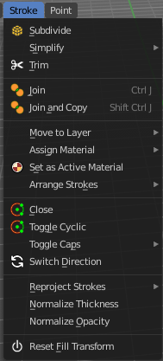
In Edit Mode you will also see a add menu for some object types. The number of objects that you can add is limited to the same object type that you are in edit mode with. You can just add mesh geometry to a mesh geometry. And just curve geometry to curve geometry.
The added objects in edit mode becomes part of the current object geometry.

Subdivide
Subdivides the selected grease pencil geometry.

Last Operator Subdivide

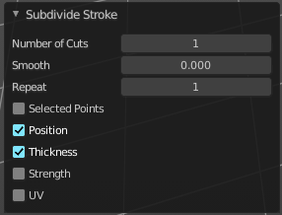
Number of Cuts
Number of subdivision cuts.

Smooth
Smoothen the stroke, not just the new added vertices

Repeat
The number of times to repeat the procedure.

Selected Points
Limits the effect to only the selected points within the stroke.

Position
The operator affects the points location.

Thickness
The operator affect the points thickness.

Strength
The operator affect the points strength (alpha).

UV
The operator affect the UV rotation on the points.

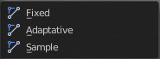
Simplify
Simplifies the stroke.

Fixed
Deletes every second point in the stroke, except the start and end points.

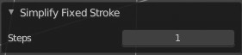
Last Operator Simplify Fixed Stroke

Steps
How much levels of simplifying.

Adaptive
This method uses an algorithm called RDP algorithm (Ramer-Douglas-Peucker algorithm) for points deletion. The algorithm tries to keep the shape with the remaining points.

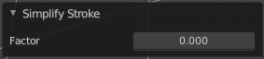
Last Operator Simplify Stroke

Factor
How strong the simplification should be performed.

Sample
Samples points along the shape of the stroke, and increases the length of the edges.

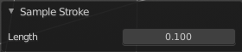
Last Operator Sample Stroke

Factor
How long the edges between the points should be.

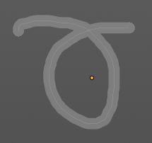
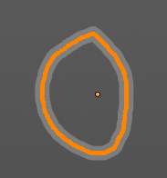
Trim
Trims down selected stroke geometry to first loop or intersection.

Join
Join selected strokes by connecting points.

Join and copy
Join selected strokes by connecting points in a new stroke.

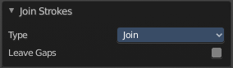
Last Operator Join Strokes

Type
Join or Join and Copy.

Leave Gaps
Don't connect the strokes by geometry.

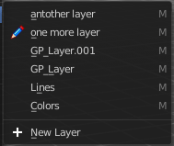
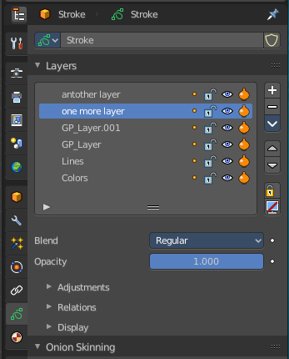
Move to Layer
Move the current selected stroke to another grease pencil layer. It lists the current layers.

New Layer
New Layer button adds a new grease pencil layer.

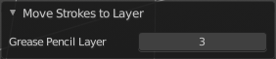
Last Operator Move Strokes to Layer

Grease Pencil Layer
Internal the layers are enumerated. So here you move by number.
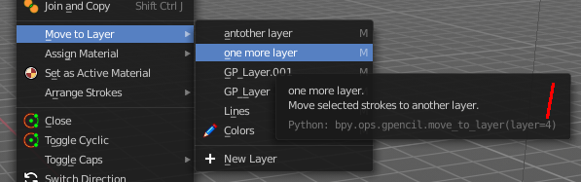
The number of a layer can be found out in the tool tip, in the Python part of it.

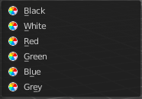
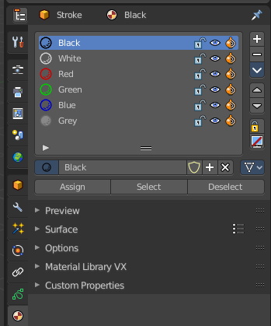
Assign Material
Assign a new material to the current selected stroke geometry.
The materials can be found and edited in the Properties editor. Here you can also create new materials.

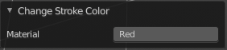
Last Operator Change Stroke Color

Material
The materials are defined by its name. So when you want to use another material, then change the name here.

Set as active material
Sets the current selected material as the active material.

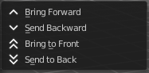
Arrange
Changes the drawing order of the strokes in the 2D layer.

Bring Forward
Moves the selected points/strokes upper the next one in the drawing order.

Send Backward
Moves the selected points/strokes below the previous one in the drawing order.

Bring to Front
Moves to the top the selected points/strokes.

Send to Back
Moves to the bottom the selected points/strokes.

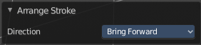
Last Operator Arrange Stroke

Direction
Choose the method again.

Close
Closes the current stroke by connecting the first vertice with the last vertice by a stroke. See also Toggle Cyclic.

Toggle Cyclic
When the curve is open, then it Closes the current stroke by connecting the first vertice with the last vertice by a stroke. When the curve is closed, then it removes the connection between first and last vertice, and makes the curve open.

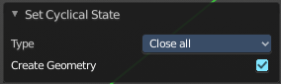
Last Operator Set Cyclical State

Type
Choose the method again.

Close all
Close all open selected strokes.

Open all
Open all closed selected strokes.

Toggle
Close or Open selected strokes as required.

Create geometry
When enabled, points are added for closing the strokes like when using the Close tool. If disabled, the stroke is closed with just one edge.

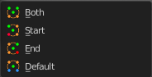
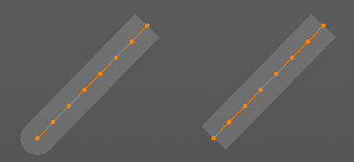
Toggle Caps
Toggles if the start and endpoints of the strokes are rounded or flat.

Default
Sets stroke start and end points to rounded (default).

Both
Toggle stroke start and end points caps to flat or rounded.

Start
Toggle stroke start point cap to flat or rounded.

End
Toggle stroke end point cap to flat or rounded.

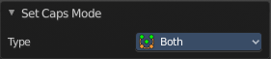
Last Operator Set Caps Mode

Type
Choose the method again.

Switch Direction
Switches the direction of the stroke geometry.

Re project Strokes
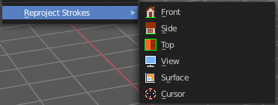
Re projects the selected stroke points in the selected view method.

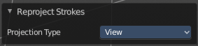
Last Operator Re project Strokes

Projection Type
Choose the method again.

Normalize Thickness
Adjust the thickness of the stroke.

Normalize Opacity
Adjust the opacity of the stroke.

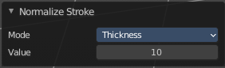
Last operator Normalize Stroke
This last operator works for both tools, Normalize Thickness and Normalize Opacity.

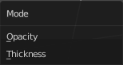
Mode
Adjust thickness or opacity.

Value
The value to adjust the opacity or thickness.

Reset Fill Transform
Reset any UV transformation back to default values.

